Q1: List down the student id along with their complete names.

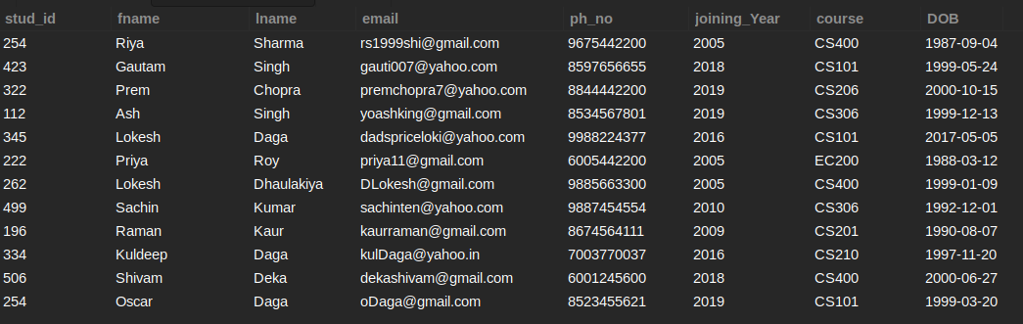

SELECT STUD_ID, FNAME, LNAME FROM STUDENT;

+---------+---------+------------+

| STUD_ID | FNAME | LNAME |

+---------+---------+------------+

| 254 | Riya | Sharma |

| 423 | Gautam | Singh |

| 322 | Prem | Chopra |

| 112 | Ash | Singh |

| 345 | Lokesh | Daga |

| 222 | Priya | Roy |

| 262 | Lokesh | Dhaulakiya |

| 499 | Sachin | Kumar |

| 196 | Raman | Kaur |

| 334 | Kuldeep | Daga |

| 506 | Shivam | Deka |

| 254 | Oscar | Daga |

+---------+---------+------------+

Q2: List down the student id along with their names and contact info like email and phone number who joined the institute in 2018.



SELECT STUD_ID, FNAME, LNAME, EMAIL, PH_NO FROM STUDENT WHERE JOINING_YEAR = 2018;

+---------+--------+-------+----------------------+------------+

| STUD_ID | FNAME | LNAME | EMAIL | PH_NO |

+---------+--------+-------+----------------------+------------+

| 423 | Gautam | Singh | gauti007@yahoo.com | 8597656655 |

| 506 | Shivam | Deka | dekashivam@gmail.com | 6001245600 |

+---------+--------+-------+----------------------+------------+  
  
  
Q3: List down all the information about the students who are enrolled in the CS400 course.



SELECT * FROM STUDENT WHERE COURSE = "CS400";

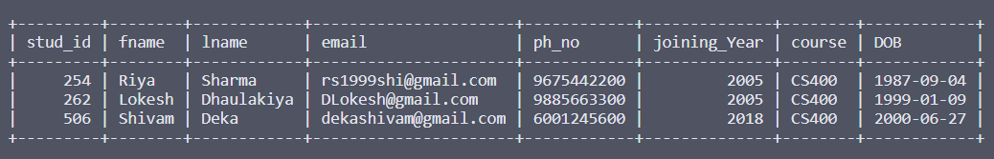

Q4: List down all the student's personal details like student id, name and contact information like email, phone number who joined the institute after 2000 and have the surname Daga.



SELECT STUD_ID, FNAME, LNAME, EMAIL, PH_NO FROM STUDENT WHERE JOINING_YEAR > 2000 and LNAME = "Daga";  
  
+---------+---------+-------+-------------------------+------------+

| STUD_ID | FNAME | LNAME | EMAIL | PH_NO |

+---------+---------+-------+-------------------------+------------+

| 345 | Lokesh | Daga | dadspriceloki@yahoo.com | 9988224377 |

| 334 | Kuldeep | Daga | kulDaga@yahoo.in | 7003770037 |

| 254 | Oscar | Daga | oDaga@gmail.com | 8523455621 |

+---------+---------+-------+-------------------------+------------+

Q5: List out all the student id’s who have either joined the institute in the year 2016 or were enrolled for CS101.



SELECT STUD_ID FROM STUDENT WHERE JOINING_YEAR = 2016 OR COURSE = "CS101";

+---------+

| STUD_ID |

+---------+

| 423 |

| 345 |

| 334 |

| 254 |

+---------+

Q6: Enlist all the students who joined the institute between the year 2009 and 2011.



SELECT * FROM STUDENT WHERE JOINING_YEAR BETWEEN 2009 AND 2011;

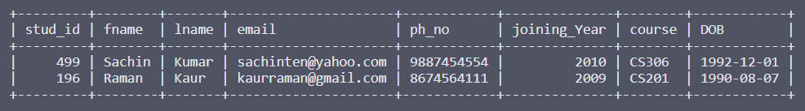

Q7: List out all the students' names (fname and lname) with their joining year and phone number who were born on and after 2nd November 1998.



SELECT FNAME, LNAME, JOINING_YEAR, PH_NO FROM STUDENT WHERE DOB > '1998-11-02';

+--------+------------+--------------+------------+

| FNAME | LNAME | JOINING_YEAR | PH_NO |

+--------+------------+--------------+------------+

| Gautam | Singh | 2018 | 8597656655 |

| Prem | Chopra | 2019 | 8844442200 |

| Ash | Singh | 2019 | 8534567801 |

| Lokesh | Daga | 2016 | 9988224377 |

| Lokesh | Dhaulakiya | 2005 | 9885663300 |

| Shivam | Deka | 2018 | 6001245600 |

| Oscar | Daga | 2019 | 8523455621 |

+--------+------------+--------------+------------+

Q8: Enlist the email ids of all the interns along with their names.

EMP_DATA

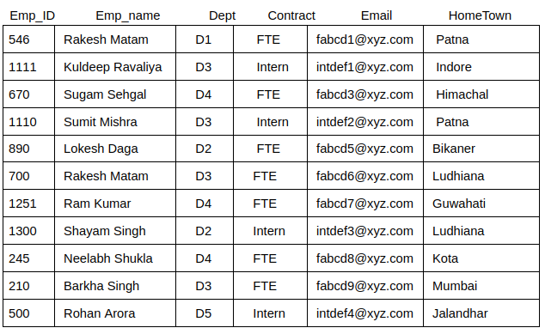

SELECT EMP_NAME, EMAIL FROM EMP_DATA WHERE CONTRACT = 'Intern';

emp_name | email

------------------+-----------------

Kuldeep Ravaliya | intdef1@xyz.com

Sumit Mishra | intdef2@xyz.com

Shayam Singh | intdef3@xyz.com

Rohan Arora | [intdef4@xyz.com](mailto:intdef4@xyz.com)

Q9: Fetch the records of all employees of Department D3 with the FTE offer.

EMP_DATA



SELECT * FROM EMP_DATA WHERE DEPT = 'D3' AND CONTRACT = 'FTE';

emp_id | emp_name | dept | contract | email | hometown

--------+--------------+------+----------+----------------+----------

700 | Rakesh Matam | D3 | FTE | fabcd6@xyz.com | Ludhiana

210 | Barkha Singh | D3 | FTE | fabcd9@xyz.com | Mumbai

Q10: Fetch all the records of the employees working for department D1 or D3.

EMP_DATA



SELECT * FROM EMP_DATA WHERE DEPT = 'D1' OR DEPT = 'D3';

emp_id | emp_name | dept | contract | email | hometown

--------+------------------+------+----------+-----------------+----------

546 | Rakesh Matam | D1 | FTE | fabcd1@xyz.com | Patna

1111 | Kuldeep Ravaliya | D3 | Intern | intdef1@xyz.com | Indore

1110 | Sumit Mishra | D3 | Intern | intdef2@xyz.com | Patna

700 | Rakesh Matam | D3 | FTE | fabcd6@xyz.com | Ludhiana

210 | Barkha Singh | D3 | FTE | fabcd9@xyz.com | Mumbai

Q11: List out all the students' names (fname and lname) and their course whose ids are 423,667,645,321,776.



SELECT FNAME, LNAME, COURSE FROM STUDENT WHERE STUD_ID IN (423,667,645,321,776);

+--------+-------+--------+

| FNAME | LNAME | COURSE |

+--------+-------+--------+

| Gautam | Singh | CS101 |

+--------+-------+--------+

Q12: Fetch all the records of the employees working for department D1 or D3 using the IN clause.

EMP_DATA



SELECT * FROM EMP_DATA WHERE DEPT IN ('D1', 'D3');

emp_id | emp_name | dept | contract | email | hometown

--------+------------------+------+----------+-----------------+----------

546 | Rakesh Matam | D1 | FTE | fabcd1@xyz.com | Patna

1111 | Kuldeep Ravaliya | D3 | Intern | intdef1@xyz.com | Indore

1110 | Sumit Mishra | D3 | Intern | intdef2@xyz.com | Patna

700 | Rakesh Matam | D3 | FTE | fabcd6@xyz.com | Ludhiana

210 | Barkha Singh | D3 | FTE | fabcd9@xyz.com | Mumbai

Q13: Fetch all the records of employees that neither work for department D1 nor for D2.

EMP_DATA



SELECT * FROM EMP_DATA WHERE DEPT NOT IN ('D1', 'D2');

emp_id | emp_name | dept | contract | email | hometown

--------+------------------+------+----------+-----------------+----------

1111 | Kuldeep Ravaliya | D3 | Intern | intdef1@xyz.com | Indore

670 | Sugam Sehgal | D4 | FTE | fabcd3@xyz.com | Himachal

1110 | Sumit Mishra | D3 | Intern | intdef2@xyz.com | Patna

700 | Rakesh Matam | D3 | FTE | fabcd6@xyz.com | Ludhiana

1251 | Ram Kumar | D4 | FTE | fabcd7@xyz.com | Guwahati

245 | Neelabh Shukla | D4 | FTE | fabcd8@xyz.com | Kota

210 | Barkha Singh | D3 | FTE | fabcd9@xyz.com | Mumbai

500 | Rohan Arora | D5 | Intern | intdef4@xyz.com | Jalandhar

Q14: List down the employee name and department that are either from Mumbai or Jalandhar and hold an employee Id numbered less than 900.

EMP_DATA



SELECT EMP_NAME, DEPT FROM EMP_DATA WHERE HOMETOWN IN ('MUMBAI', 'JALANDHAR') AND EMP_ID < 900;

+--------------+------+

| EMP_NAME | DEPT |

+--------------+------+

| Barkha Singh | D3 |

| Rohan Arora | D5 |

+--------------+------+

Q15: List down the complete names of the students from batch 2019 (who joined in 2019) and the second letter of their first name is "s".



SELECT FNAME, LNAME FROM STUDENT WHERE FNAME LIKE '_S%'

+-------+-------+

| FNAME | LNAME |

+-------+-------+

| Ash | Singh |

| Oscar | Daga |

+-------+-------+

Q16: List down all the student information who use Yahoo as their emails.



SELECT * FROM STUDENT WHERE EMAIL LIKE '%YAHOO%';

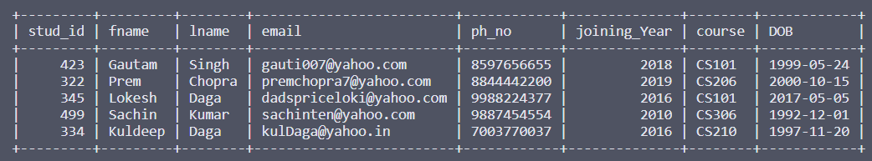

Q17: Fetch all the records with Email ID’s starting from ‘fab’.

EMP_DATA



SELECT * FROM EMP_DATA WHERE EMAIL LIKE 'fab%';

emp_id | emp_name | dept | contract | email | hometown

--------+----------------+------+----------+----------------+----------

546 | Rakesh Matam | D1 | FTE | fabcd1@xyz.com | Patna

670 | Sugam Sehgal | D4 | FTE | fabcd3@xyz.com | Himachal

890 | Lokesh Daga | D2 | FTE | fabcd5@xyz.com | Bikaner

700 | Rakesh Matam | D3 | FTE | fabcd6@xyz.com | Ludhiana

1251 | Ram Kumar | D4 | FTE | fabcd7@xyz.com | Guwahati

245 | Neelabh Shukla | D4 | FTE | fabcd8@xyz.com | Kota

210 | Barkha Singh | D3 | FTE | fabcd9@xyz.com | Mumbai

Q18: List down all the employee id’s and names whose Email contains ‘bcd’ and belongs to department D3 or D4 but aren’t from Himachal, Guwahati.

EMP_DATA



SELECT EMP_ID, EMP_NAME FROM EMP_DATA WHERE EMAIL LIKE '%bcd%' AND DEPT IN ('D3', 'D4') AND HOMETOWN NOT IN ('HIMACHAL', 'GUWAHATI');

+--------+----------------+

| EMP_ID | EMP_NAME |

+--------+----------------+

| 700 | Rakesh Matam |

| 245 | Neelabh Shukla |

| 210 | Barkha Singh |

+--------+----------------+